
SCHOOL NAME: __________________________ EXAMINATION NO: ________________________
SOUTH EAST EDUCATION DIVISION
2025 MALAWI SCHOOL CERTIFICATE OF EDUCATION MOCK EXAMINATION

GEOGRAPHY

Subject Number: M073/I
Tuesday, 1st April Time Allowed: 2 hr 30min
8:00 – 10:00 am

PAPER I
(100 marks)
MAP READING AND PHYSICAL GEOGRAPHY

Instructions
Question  Number | Tick if answered | Do not write in these columns
1
2
3
4
5
- This paper contains 9 printed pages.
Please check.

- This paper has five questions.

- This paper has two sections: A and B.

- Answer all the three questions in section A and any one question in Section B.

- Write your Examination number and School Name on top of each page of this question paper.

- In the table provided on this page, tick against the number of question you have answered.
- Hand in your question paper to the invigilator when time is called to stop writing.

© 2025 SEED MOCK Turn over/…

SECTION A (75 marks)
Answer all the three questions in the spaces provided
- Study the map extract of Kasungu provided and use it to answer the questions that follow:
a (i) Give the six-figure grid reference of the borehole BM SM 53
_______________________________________________________________ (2 marks)
(ii) Name the human feature found at grid reference 354777
_______________________________________________________________ (1 mark)
b. (i) Identify the settlement patterns displayed by the following:
1. Chisuulu village_______________________________________________ (1 mark)
2. Mphampha village ____________________________________________ (1 mark)
(ii) What type of drainage pattern is shown by Dwangwa River between easting 36 and
easting 39?
________________________________________________________________ (1 mark)
(iii) Give the two land uses shown on the map extract
_______________________________________________________________________________________________________________________________________ (2 marks)
c. (i) State whether or not Zanda village (3782) is intervisible from Mtuta village (3384).
Give a reason for your answer.
_______________________________________________________________________________________________________________________________________ (2 marks)
(ii) Describe the general relief of the land covered by the map extract.
________________________________________________________________________________________________________________________________________ (2 marks)
d (i) Calculate the average gradient of T324 road between easting 35 and easting 38.
Take 50 feet to represent 15 meters

(5 marks)
(ii) Measure the angular bearing of the trigonometrical station at Kambulu from the
borehole BH GK 120.
______________________________________________________________ (2 marks)
e. On the graph paper provided, draw a cross section between easting 32 and easting 36
along northing 85. On your cross section, show the position of T323 road. Take 1 cm
to represent 50 feet for vertical scale

Continued/…
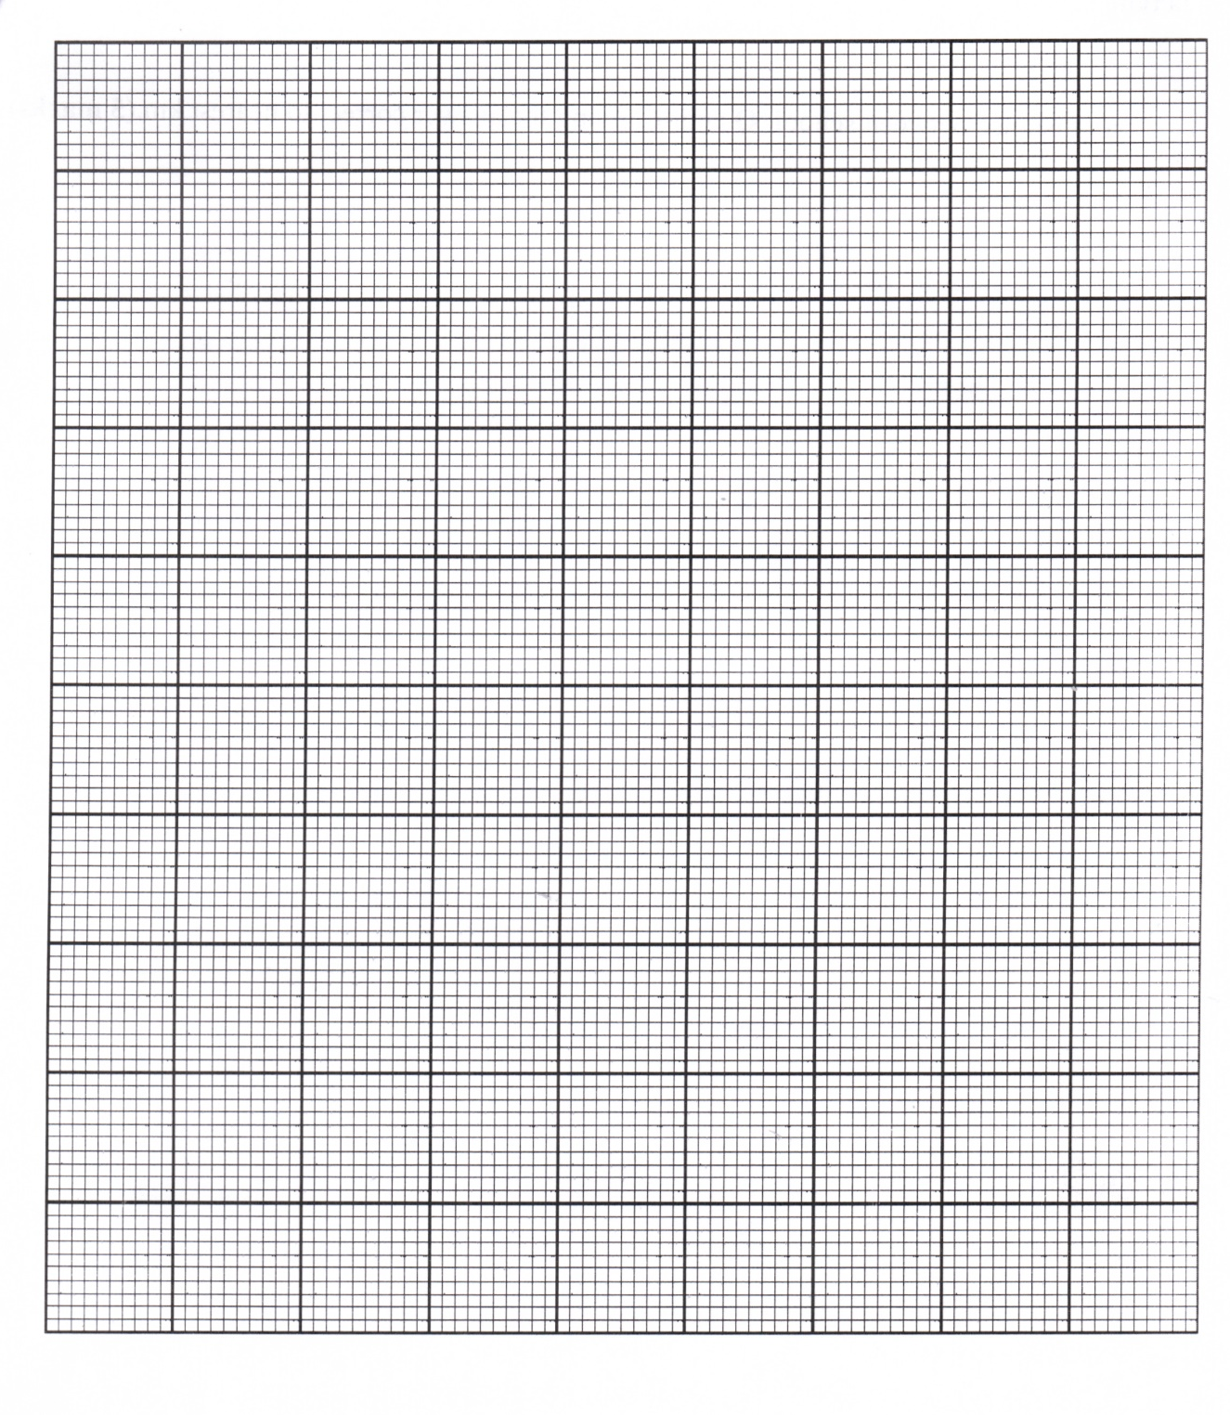
(6 marks)
2. a. The table below shows pressure and temperature trends. Use it to answer the
questions that follow.
Height in meters | Pressure (mb) | Temperature (degrees celsius)
5000 | 606 | -9
3000 | 717 | 7
1500 | 842 | 16
Sea level | 1012 | 25
(i). Calculate the pressure difference between sea level and 5000 meters
________________________________________________________________________________________________________________________________________ (2 marks)
(ii). Calculate the temperature change between 1500 meters and 5000 meters
________________________________________________________________________________________________________________________________________ (2 marks)
(iii). Account for the difference in pressure pattern between sea level and 3000 meters.
________________________________________________________________________________________________________________________________________ (2 marks)
b. Explain reasons for the following:
(i) Occurrences of hot deserts along the 30 degrees pressure belts
________________________________________________________________________________________________________________________________________ (2 marks)
(ii) Occurrences of cyclonic storms along the 60 degrees belts
________________________________________________________________________________________________________________________________________ (2 marks)
c (i) Explain any two ways in which climate may be affected by air pollution
________________________________________________________________________________________________________________________________________________________________________________________________________________________________________________________________________________________ (4 marks)
(ii) Describe how afforestation can help to arrest the effects of air pollution
________________________________________________________________________________________________________________________________________ (2 marks)
d (i) Give any two differences between ocean streams and ocean drifts
________________________________________________________________________________________________________________________________________________________________________________________________________________________________________________________________________________________ (4 marks)
(ii) How do prevailing winds influence the direction of ocean currents?
________________________________________________________________________________________________________________________________________ (1 mark)
(iii) Explain any two negative effects of ocean currents on water transport
________________________________________________________________________________________________________________________________________________________________________________________________________________________________________________________________________________________ (4 marks)

Continued/…
3 a. Figure 1 shows the world crustal plates and their boundaries. Use it to
answer the questions that follow:
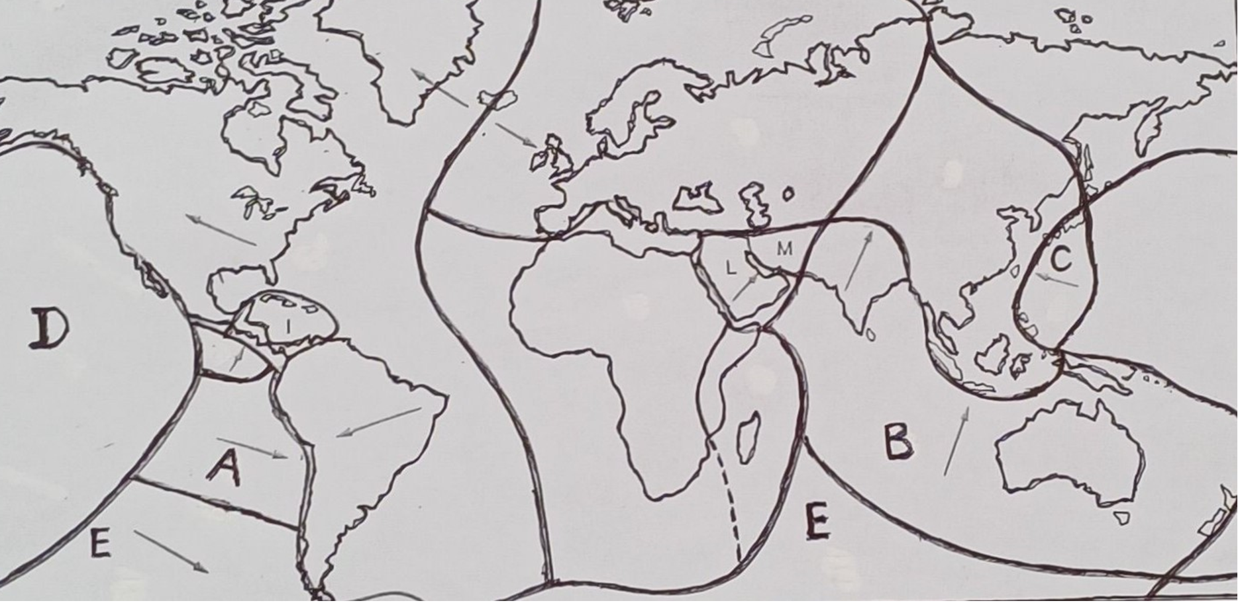
Figure 1
(i) Identify the crustal plates labeled A and B
A ___________________________________________________________________
B __________________________________________________________(2 marks)
(ii) What type of crustal plates is crustal plate C?
____________________________________________________________(1 mark)
- On the map itself:
1. Locate and name the ocean ridge in the Atlantic Ocean (2 marks)
2. Using an arrow show the direction of movement of crustal plate D (2 marks)
(iv) Explain how crustal plate marked E helps to prove the theory of continental drifting
________________________________________________________________________________________________________________________________________ (2 marks)
b (i) Mention any two fold mountains in the Eurasian region
________________________________________________________________________________________________________________________________________ (2 marks)
(ii) Explain any two influence of fold mountains on the climate of the regions they are
found.
________________________________________________________________________________________________________________________________________________________________________________________________________________________________________________________________________________________(4 marks)
c (i) State any two natural causes of climate change.
________________________________________________________________________________________________________________________________________ (2 marks)
Continued/…
(ii) Explain how global warming influences rising of sea levels.
_______________________________________________________________________________________________________________________________________ (2 marks)
d. (i) Draw a clearly labeled diagram of a volcano.

(3 marks)
(ii) Explain why the eastern part of the African continent is prone to volcanic activities?
______________________________________________________________________
______________________________________________________________________
______________________________________________________________ (3 marks
SECTION B (25marks)
Answer one question only in this section in the spaces provided.
4. a. Figure 2 shows vegetation photo and use it to answer the questions that
follow:
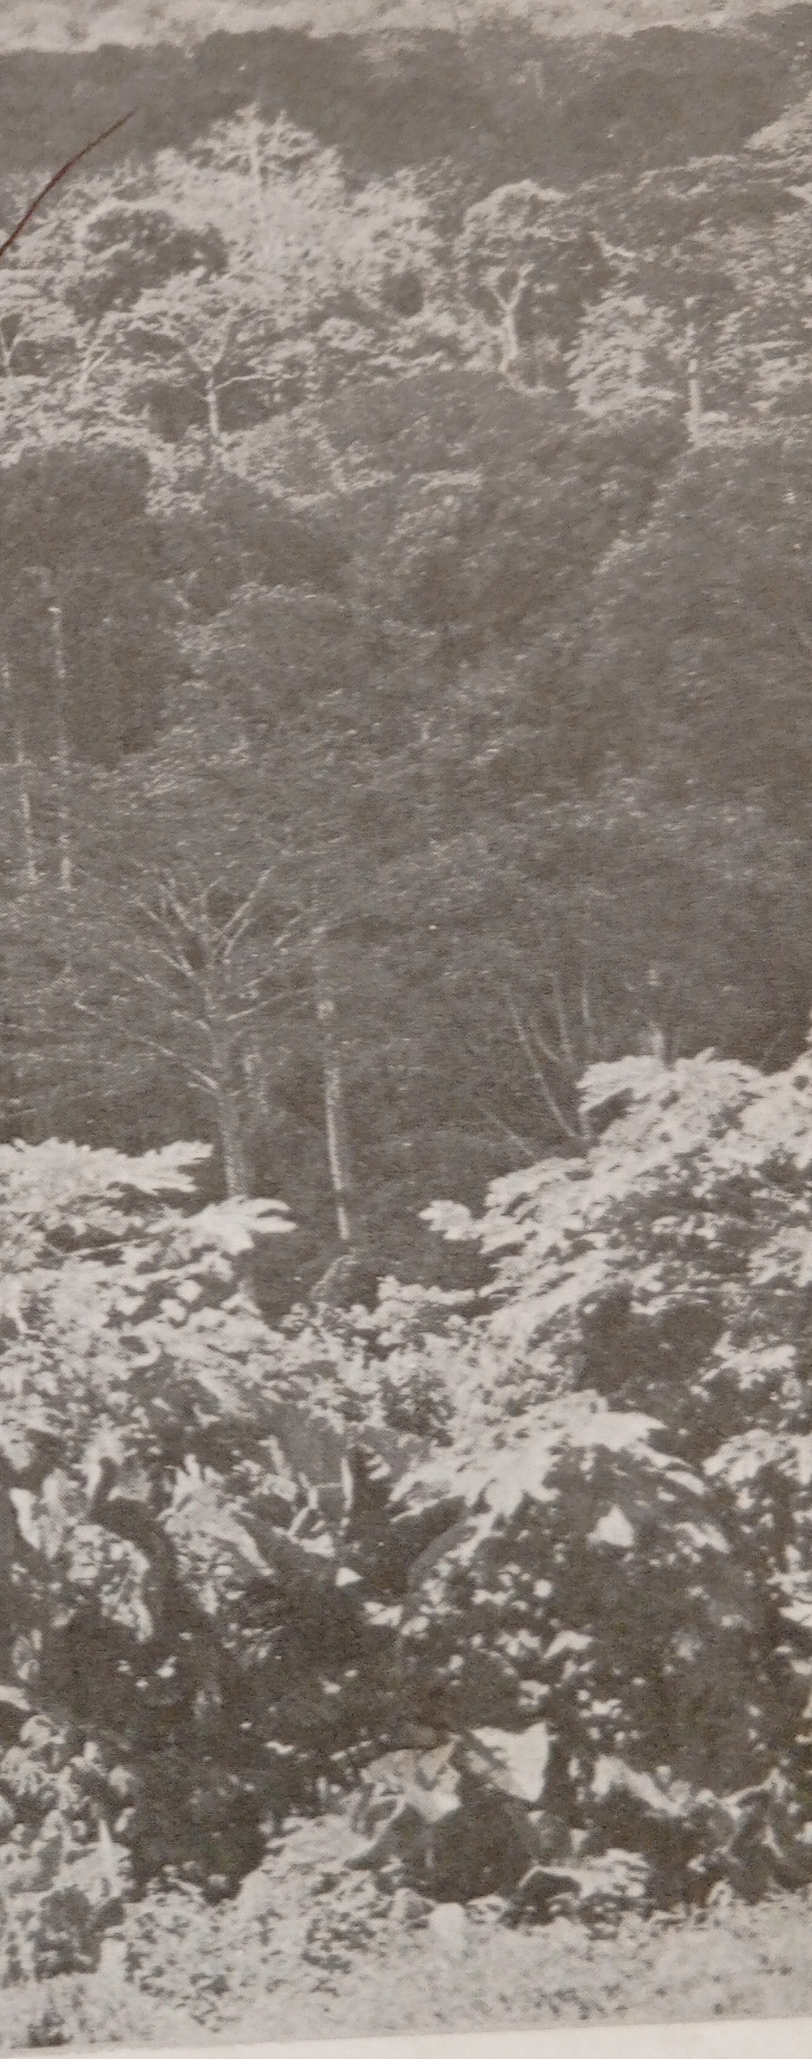
Figure 2
(i) Name the vegetation type shown in the figure
______________________________________________________________ (1 mark)
Continued/…
(ii) Name any two countries outside Africa with the climate having this vegetation.
_____________________________________________________________________________________________________________________________________________ (2 marks)
(iii) Describe the rainfall and temperature patterns of the climate with this vegetation.
Rainfall pattern: ________________________________________________________________
________________________________________________________________ (2 marks)
Temperature pattern: ________________________________________________________________
_________________________________________________________________ (2 marks)
(iv). Describe any two ways in which the vegetation in the figure adapts to the climatic
conditions in which it is found
___________________________________________________________________________________________________________________________________________________________________________________________________________________________________________________________________________________________________ (4 marks)
b. Study the figure that shows one of the world local winds. Use it answer the questions that
follow:
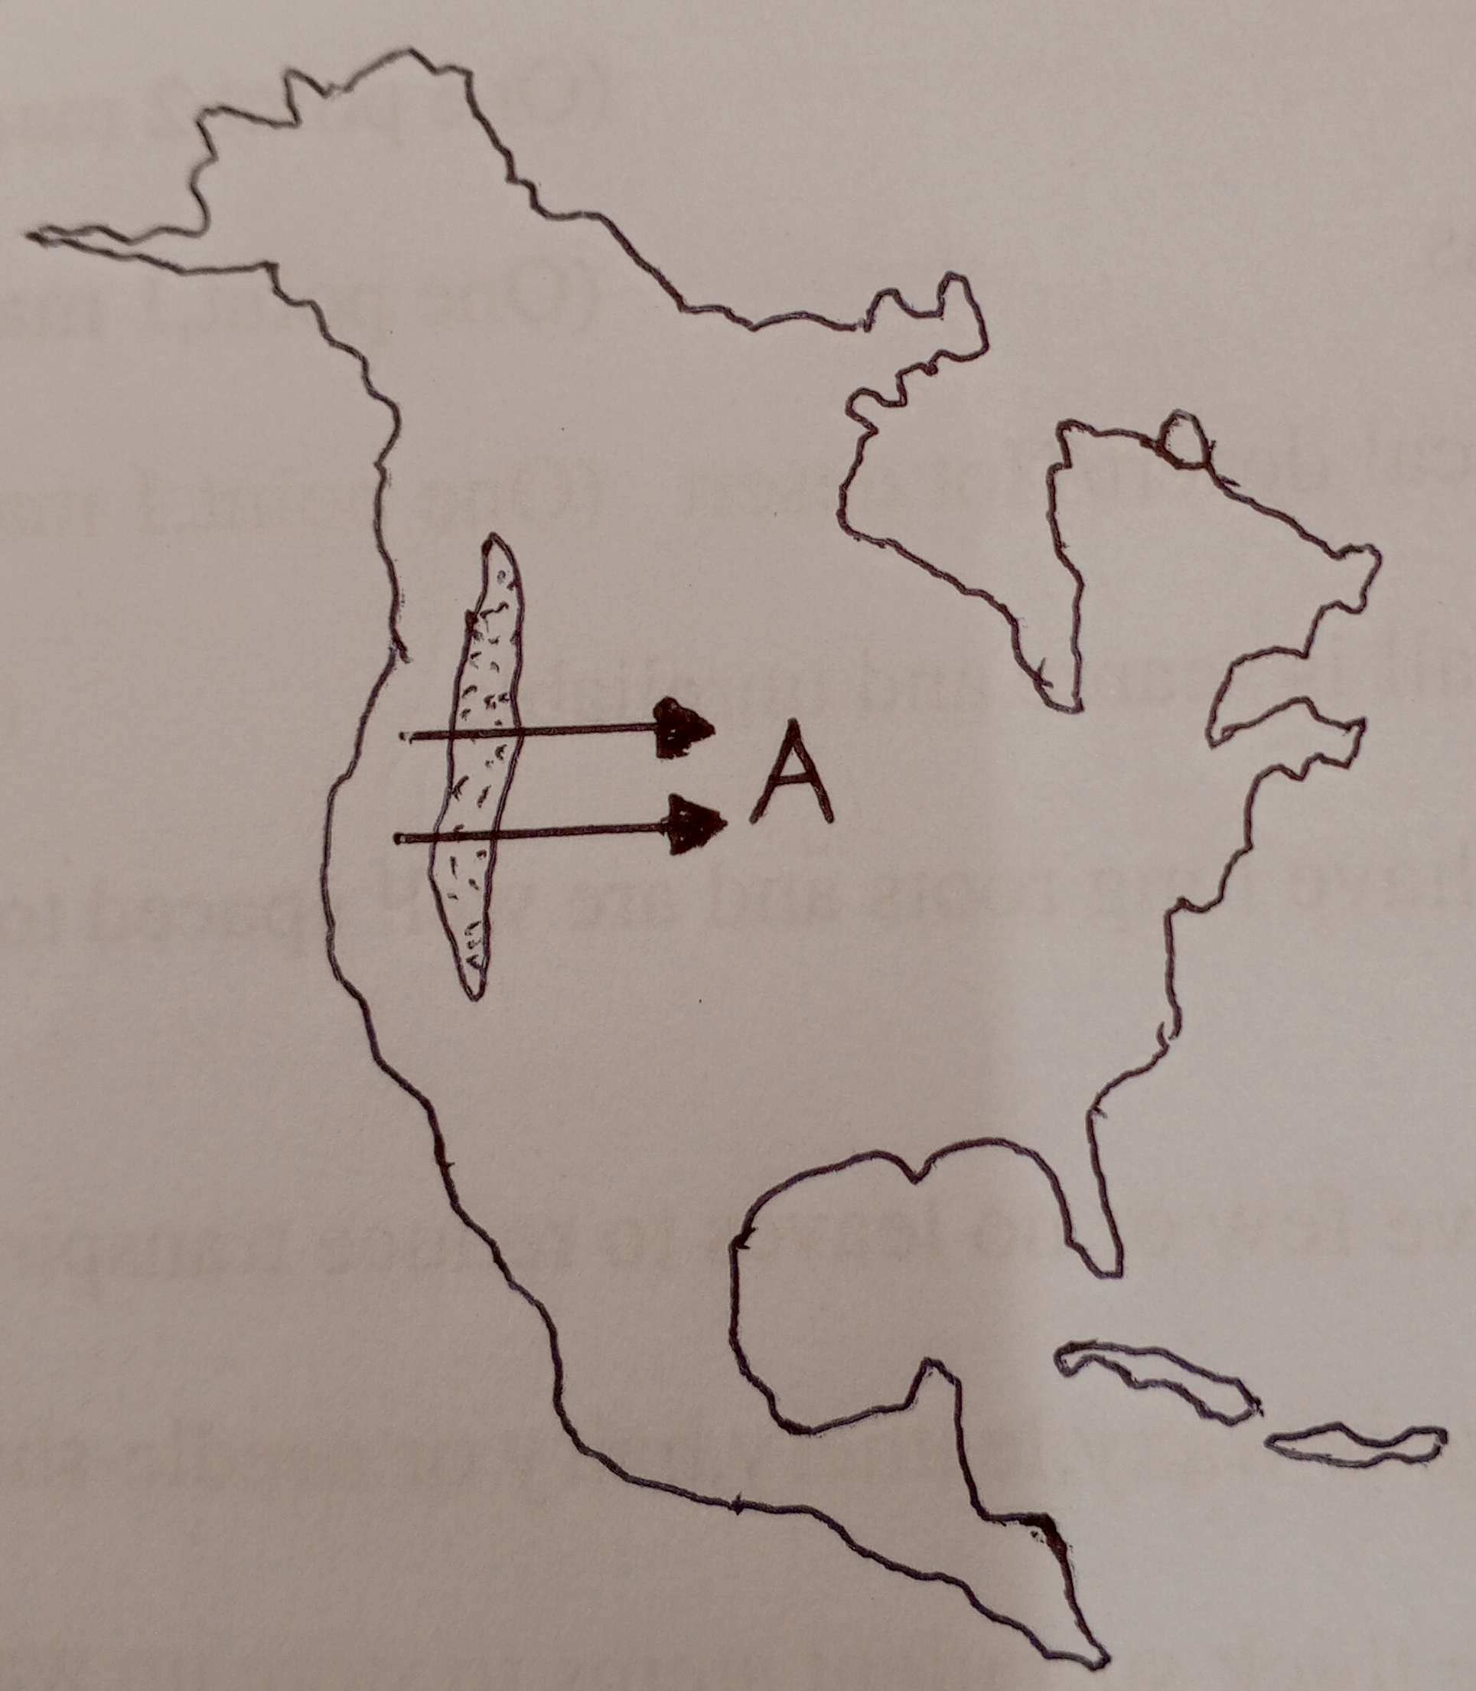
(i) Name the local wind labeled A.
________________________________________________________________ (1 mark)
(ii) Give any two characteristics of the local wind A
________________________________________________________________________________________________________________________________________ (2 marks)
(iii) Explain how the wind mentioned above assist in farming activities in North America.
_________________________________________________________________________
________________________________________________________________ (2 marks)
c. (i) Explain how bays are formed in relation to headlands.
_______________________________________________________________________________________________________________________________________________________________________________________________________________________________________________________________________________________________________________ (4 marks)
(ii) Give any two economic values of deltas
___________________________________________________________________________________________________________________________________________________ (2 marks)
d (i). Give any two human causes of earthquakes
___________________________________________________________________________________________________________________________________________________ (2 marks)
(ii). Explain the main reason for the frequency of earthquakes in areas associated with
volcanoes
___________________________________________________________________________________________________________________________________________________ (2 marks)

5 a (i) Give one difference between a stable air mass and an unstable air mass
___________________________________________________________________________________________________________________________________________________ (2 marks)
(ii)State any two ways in which air masses are classified
___________________________________________________________________________________________________________________________________________________ (2 marks)
(iii) Name the air masses that are experienced in the following regions
1. North Africa ___________________________________________________ (1 mark)
2. Antarctic region _________________________________________________ (1 mark)
b) Figure 3 shows a front. Use it to answer the questions that follow:
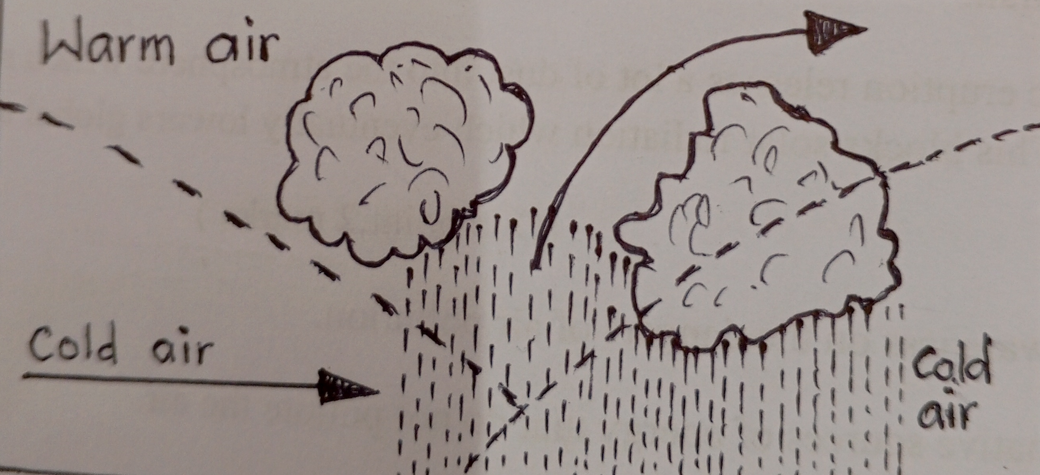
Figure 3
(i) Identify the type of front shown in the figure
______________________________________________________________________ (1 mark)
(ii) Describe how this front is formed.
_________________________________________________________________________________________________________________________________________________________________________________________________________________________________ (3 marks)
c. Study the table that shows the climatic statistics for Station Y. Use it to answer the questions
that follow.
Month | J | F | M | A | M | J | J | A | S | O | N | D
Temp °C | 7 | 8 | 11 | 18 | 22 | 22 | 24 | 24 | 21 | 17 | 12 | 8
Rain(mm) | 81 | 69 | 74 | 66 | 56 | 41 | 18 | 25 | 64 | 127 | 112 | 99

(i). Identify the type of climate represented by the table
________________________________________________________________ (1 mark)
(ii). In which hemisphere is station Y located? Give a reason for your answer.
________________________________________________________________________________________________________________________________________________________________________________________________________________________ (3 marks)
(iii). Explain the main cause of the climate shown in the table
_____________________________________________________________________________________________________________________________________________ (2 marks)
(iv). Name any two countries that experience this climate in Africa
_______________________________________________________________________________________________________________________________________________ (2 marks)
(v). Give any two main economic developments that are carried out in this climatic region.
_______________________________________________________________________________________________________________________________________________ (2 marks)
d. (i) To which groups of rocks do the following rocks belong:
1. Basalt __________________________________________________________ (1 mark)
2. Gneiss __________________________________________________________ (1 mark)
(ii) Describe how sedimentary rocks are organically formed
_______________________________________________________________________________________________________________________________________________ (2 marks)
(iii) Give any one economic importance of rocks
____________________________________________________________________ (1 mark)
END OF QUESTION PAPER
NB: This paper contains 9 printed pages

